主要错误：

TASK [Install erpnext app] *****************************************************

fatal: [localhost]: FAILED! => {"changed": true, "cmd": ["bench", "--site", "site1.local", "install-app", "erpnext"], "delta": "0:00:02.203465", "end": "2017-03-03 00:49:10.914772", "failed": true, "rc": 1, "start": "2017-03-03 00:49:08.711307", "stderr": "Traceback (most recent call last):\n File \"/usr/lib/python2.7/runpy.py\", line 174, in _run_module_as_main\n \"__main__\", fname, loader, pkg_name)\n File \"/usr/lib/python2.7/runpy.py\", line 72, in _run_code\n exec code in run_globals\n File \"/home/frappe/frappe-bench/apps/frappe/frappe/utils/bench_helper.py\", line 79, in <module>\n main()\n File \"/home/frappe/frappe-bench/apps/frappe/frappe/utils/bench_helper.py\", line 16, in main\n click.Group(commands=commands)(prog_name='bench')\n File \"/home/frappe/frappe-bench/env/local/lib/python2.7/site-packages/click/core.py\", line 722, in __call__\n return self.main(*args, **kwargs)\n File \"/home/frappe/frappe-bench/env/local/lib/python2.7/site-packages/click/core.py\", line 697, in main\n rv = self.invoke(ctx)\n File \"/home/frappe/frappe-bench/env/local/lib/python2.7/site-packages/click/core.py\", line 1066, in invoke\n return _process_result(sub_ctx.command.invoke(sub_ctx))\n File \"/home/frappe/frappe-bench/env/local/lib/python2.7/site-packages/click/core.py\", line 1066, in invoke\n return _process_result(sub_ctx.command.invoke(sub_ctx))\n File \"/home/frappe/frappe-bench/env/local/lib/python2.7/site-packages/click/core.py\", line 895, in invoke\n return ctx.invoke(self.callback, **ctx.params)\n File \"/home/frappe/frappe-bench/env/local/lib/python2.7/site-packages/click/core.py\", line 535, in invoke\n return callback(*args, **kwargs)\n File \"/home/frappe/frappe-bench/env/local/lib/python2.7/site-packages/click/decorators.py\", line 17, in new_func\n return f(get_current_context(), *args, **kwargs)\n File \"/home/frappe/frappe-bench/apps/frappe/frappe/commands/__init__.py\", line 24, in _func\n ret = f(frappe._dict(ctx.obj), *args, **kwargs)\n File \"/home/frappe/frappe-bench/apps/frappe/frappe/commands/site.py\", line 152, in install_app\n _install_app(app, verbose=context.verbose)\n File \"/home/frappe/frappe-bench/apps/frappe/frappe/installer.py\", line 132, in install_app\n sync_for(name, force=True, sync_everything=True, verbose=verbose, reset_permissions=True)\n File \"/home/frappe/frappe-bench/apps/frappe/frappe/model/sync.py\", line 44, in sync_for\n import_file_by_path(doc_path, force=force, reset_permissions=reset_permissions)\n File \"/home/frappe/frappe-bench/apps/frappe/frappe/modules/import_file.py\", line 57, in import_file_by_path\n reset_permissions=reset_permissions)\n File \"/home/frappe/frappe-bench/apps/frappe/frappe/modules/import_file.py\", line 125, in import_doc\n doc.insert()\n File \"/home/frappe/frappe-bench/apps/frappe/frappe/model/document.py\", line 212, in insert\n self.run_post_save_methods()\n File \"/home/frappe/frappe-bench/apps/frappe/frappe/model/document.py\", line 768, in run_post_save_methods\n self.run_method(\"on_update\")\n File \"/home/frappe/frappe-bench/apps/frappe/frappe/model/document.py\", line 651, in run_method\n out = Document.hook(fn)(self, *args, **kwargs)\n File \"/home/frappe/frappe-bench/apps/frappe/frappe/model/document.py\", line 858, in composer\n return composed(self, method, *args, **kwargs)\n File \"/home/frappe/frappe-bench/apps/frappe/frappe/model/document.py\", line 841, in runner\n add_to_return_value(self, fn(self, *args, **kwargs))\n File \"/home/frappe/frappe-bench/apps/frappe/frappe/model/document.py\", line 645, in <lambda>\n fn = lambda self, *args, **kwargs: getattr(self, method)(*args, **kwargs)\n File \"/home/frappe/frappe-bench/apps/frappe/frappe/core/doctype/doctype/doctype.py\", line 197, in on_update\n self.run_module_method(\"on_doctype_update\")\n File \"/home/frappe/frappe-bench/apps/frappe/frappe/core/doctype/doctype/doctype.py\", line 206, in run_module_method\n module = load_doctype_module(self.name, self.module)\n File \"/home/frappe/frappe-bench/apps/frappe/frappe/modules/utils.py\", line 173, in load_doctype_module\n raise ImportError, 'Module import failed for {0} ({1})'.format(doctype, module_name)\nImportError: Module import failed for Sales Invoice (erpnext.accounts.doctype.sales_invoice.sales_invoice)", "stdout": "Installing erpnext...\n\rUpdating erpnext…

——Frappe 其中一个 模组 运行失败

解决方法：rm -rf frappe-bench/apps/frappe

bench get-app frappe <https://gitlab.moshimori.com/steven/frappe.git>

bench —site $sitename install-app erpnext （成功）

对于 **Frappe & Bench** 做出的改动如下

* bench/playbook/production/includes/setup_bench_production.yml (应该是 install.py 会去执行的文件之一)

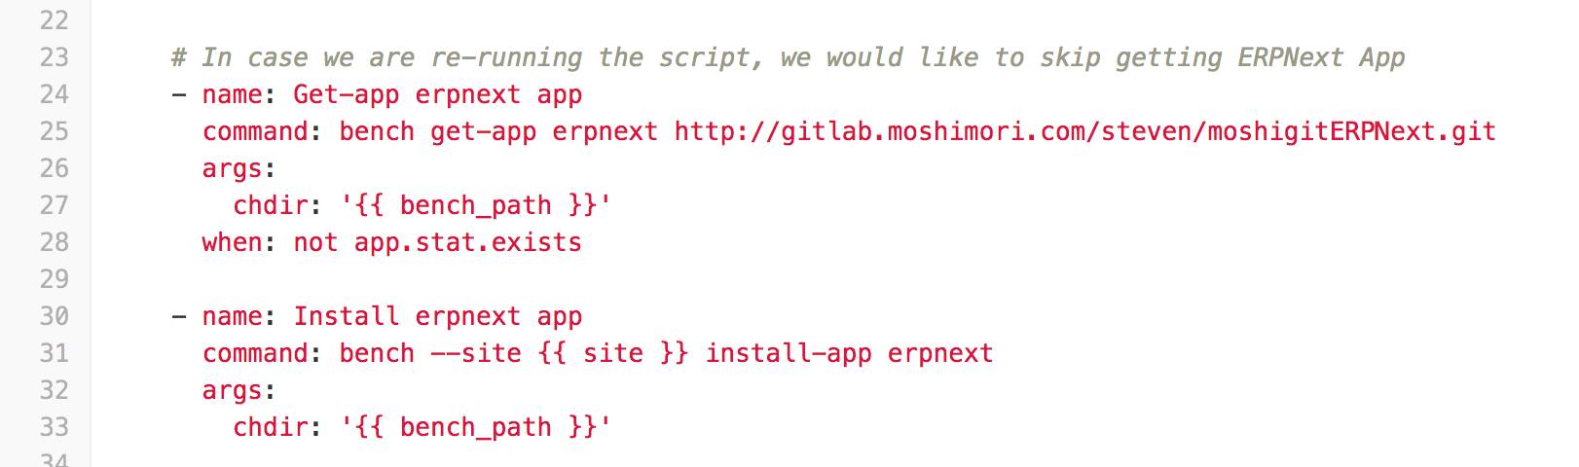

25行 — 修改 ”bench get-app erpn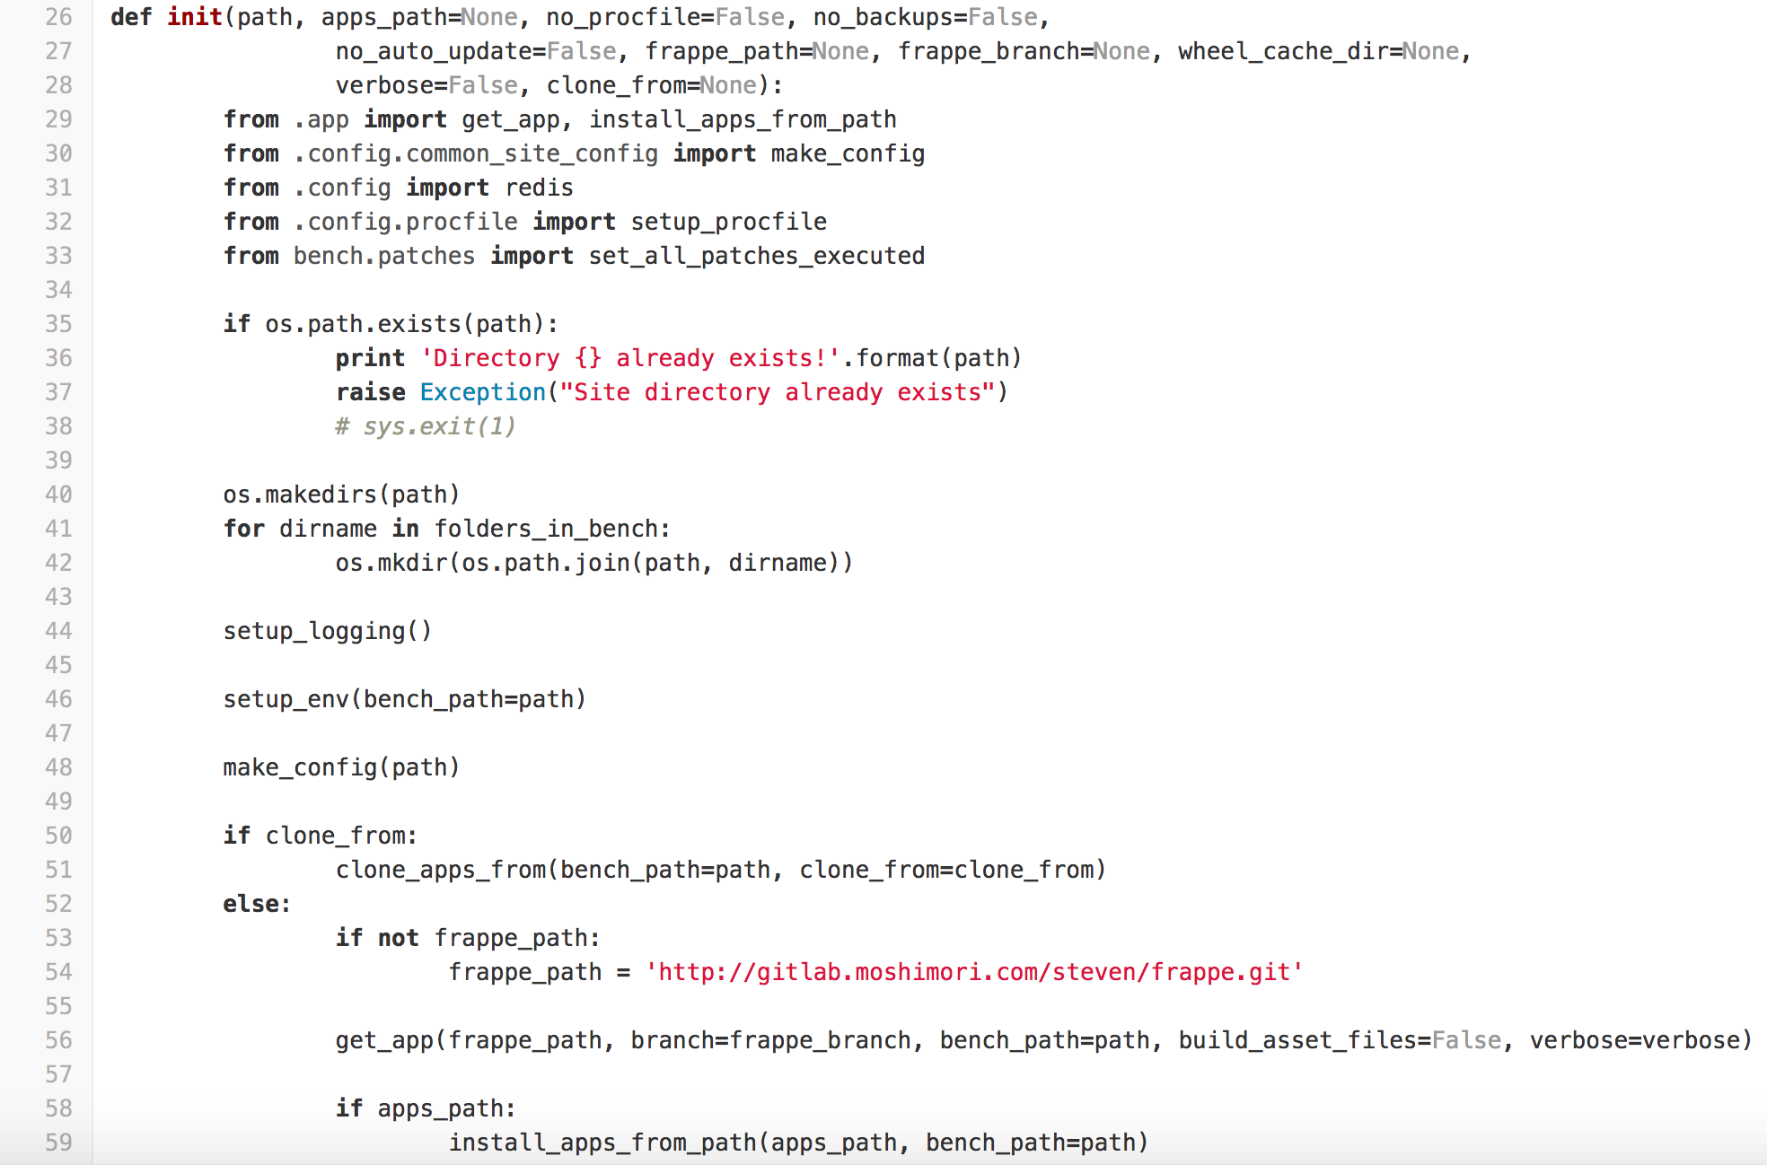ext” 下载路径

* bench/bench/utils.py （bench 下的 指令 集合）

54 行 — 因为 bench init frappe-bench 是用来装 frappe-bench 文件夹，函数 init 相关 路径 进行改动

* bench/install_scripts/setup_frappe.sh （安装 环境 + 所需组建& frappe）

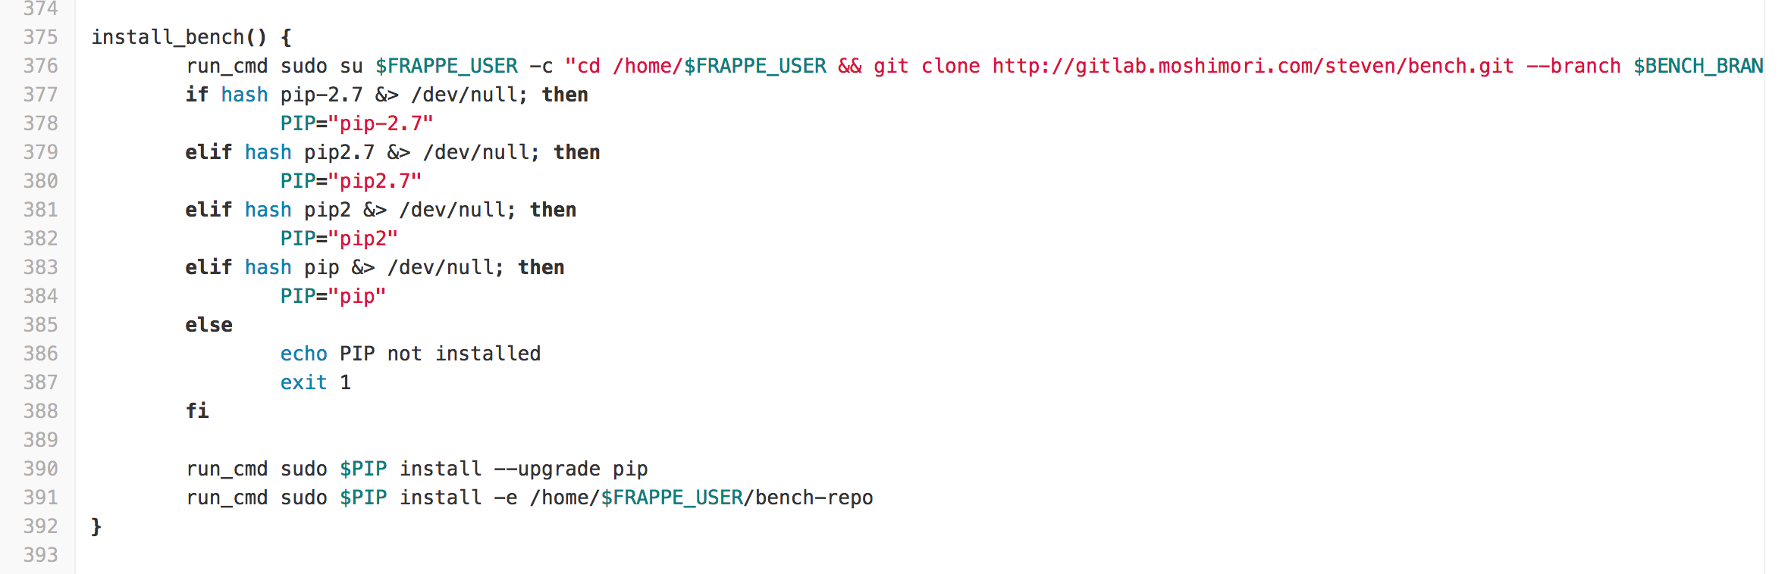

376 行 — 修改 git clone 路径

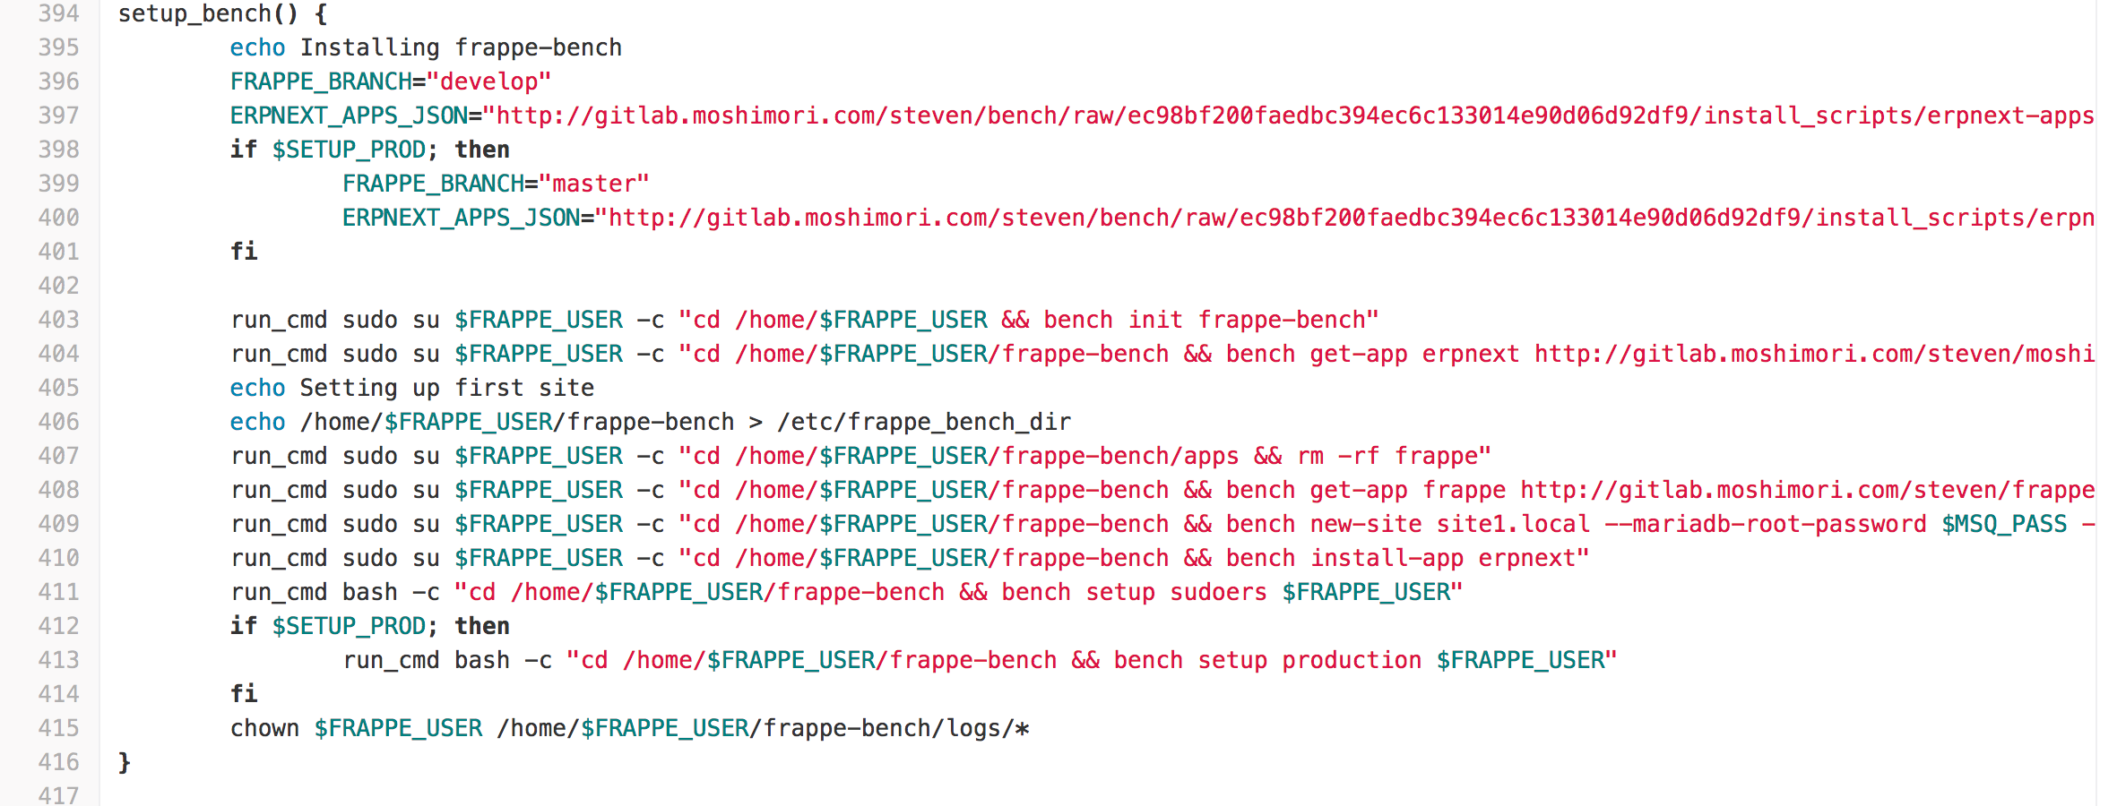

397 & 400 行 — 修改 ERPNEXT_APPS_JSON 文字档案 路径

403 ～ 407 行 — 因为 直接 install.py 下载的 apps/frappe 有问题，试着 删除 & 重新下载，可惜 仍然没有解决

* bench/install_scripts/erpnext-apps-master.json
* bench/install_scripts/erpnext-apps.json

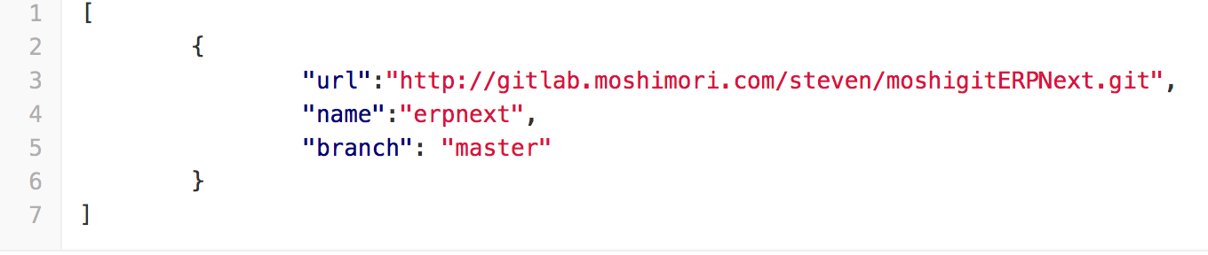

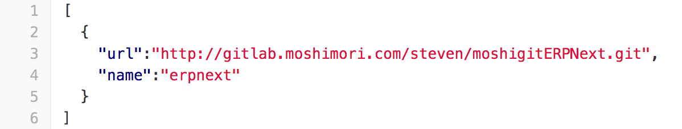

3 行 — 修改 url